Northern shared chronic pain services
Understanding Chronic Pain
A guide for patients and their families
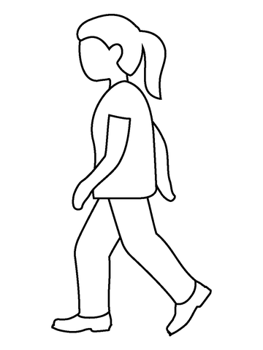

Understanding Chronic Pain
A simple guide for patients

Your Body’s Threat Detector
Pain is something almost everyone feels at some point in their life. It can be uncomfortable, even overwhelming. But pain isn’t just a problem; it’s one of your body’s most important ways to protect you. Its job is simple: to keep you safe.
One helpful way to understand pain is to think about a smoke detector.
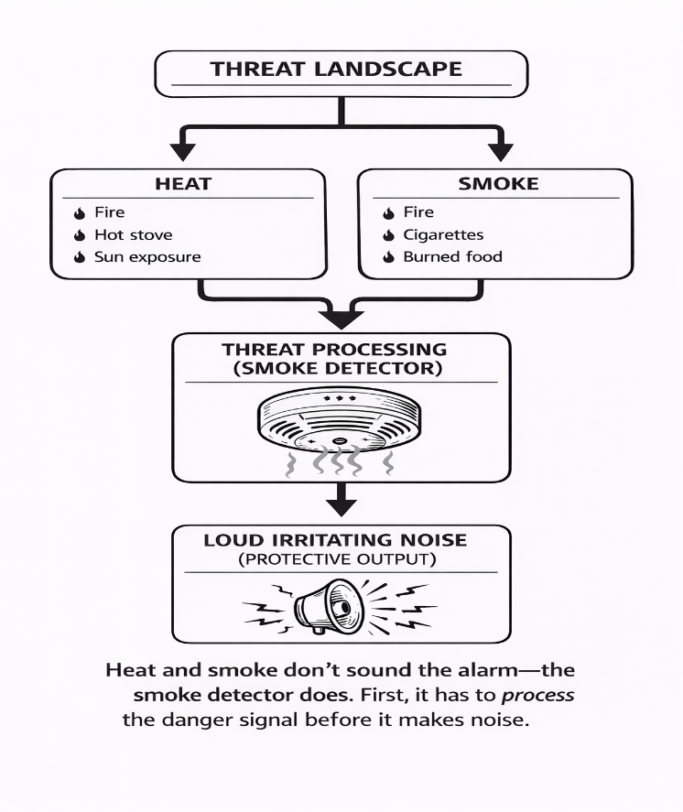
A smoke detector is loud, protective, and not very specific. Its job is to watch for signs of danger, like smoke or heat. But smoke and heat are not the alarm itself. They are just warning signals that something might be wrong.
When the detector notices those signals, it sounds a loud, annoying alarm. The alarm is designed to grab your attention quickly so you can act and stay safe.
Here’s the important part: the smoke detector doesn’t actually know if there is a real fire. It can’t tell you exactly where the problem is, or even if there is true danger. It simply reacts to the information it receives and tries to protect you “just in case.”
Your pain system works in a very similar way.
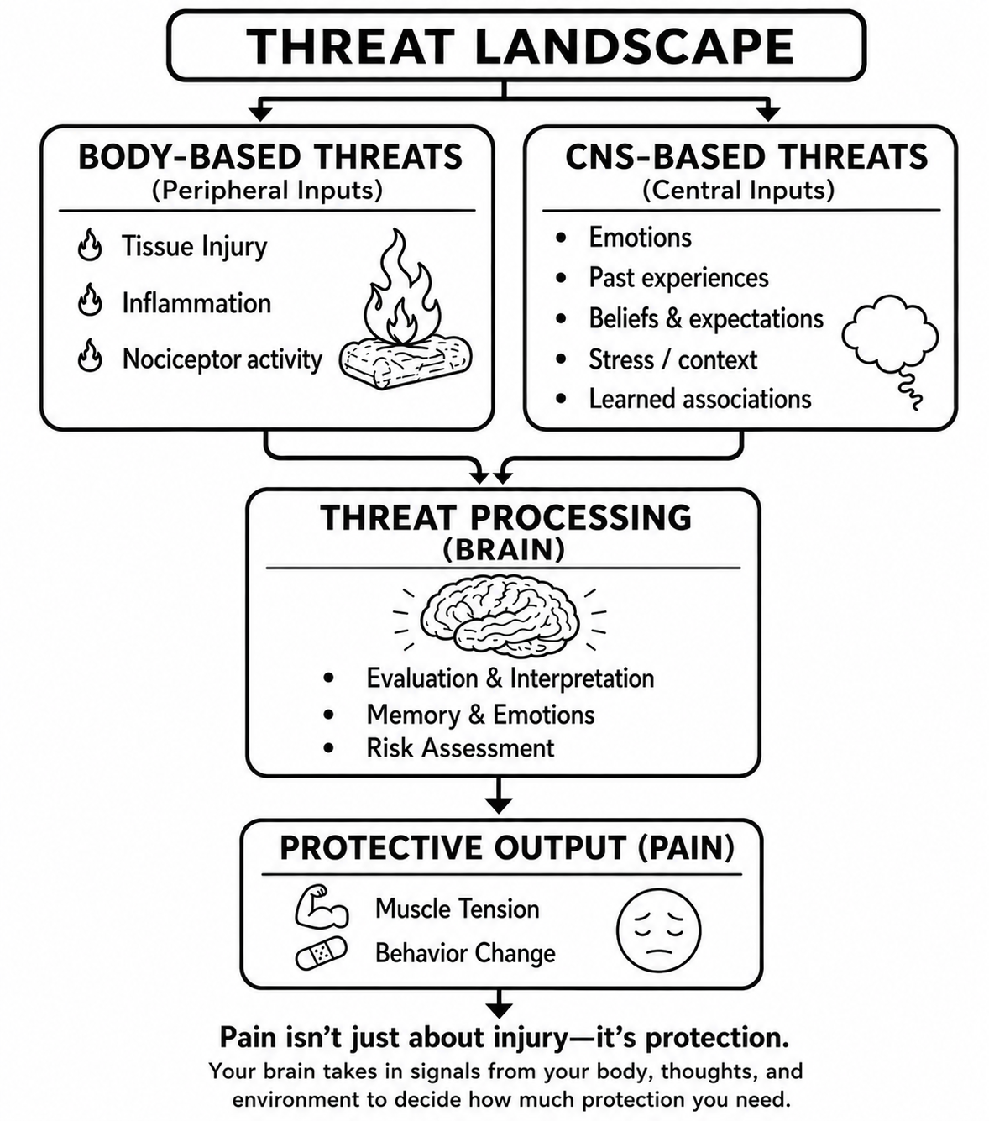
Your body has special sensors that are always watching for danger. These sensors can detect things like injury, strain, heat, or infection. When you twist your ankle or cut your skin, they send warning messages through your spinal cord up to your brain.
But the brain does more than just listen to the body. It also looks at things like fear, stress, memories, past experiences, and learned patterns. It is constantly asking: “Is this safe, or do I need to protect you?”
If the brain believes there may be danger, it can create the sensation of pain. Pain is a protective response designed to grab your attention and get you to act. It may encourage you to slow down, protect the area, rest, or ask for help.
In the early stages after an injury, this system is very helpful. It helps your body heal and keeps you safe.
But sometimes; through no fault of your own; your brain can start to fear the feeling of pain itself causing the system to become overprotective.
When that happens, everyday things can start to set off the alarm. Simple activities like walking, going to physiotherapy, or even changes in the weather can trigger pain. Over time, your brain begins to think: “This isn’t safe.”
The more often this happens, the more protective the system becomes. It starts to sound the alarm more quickly; even during normal, safe activities.
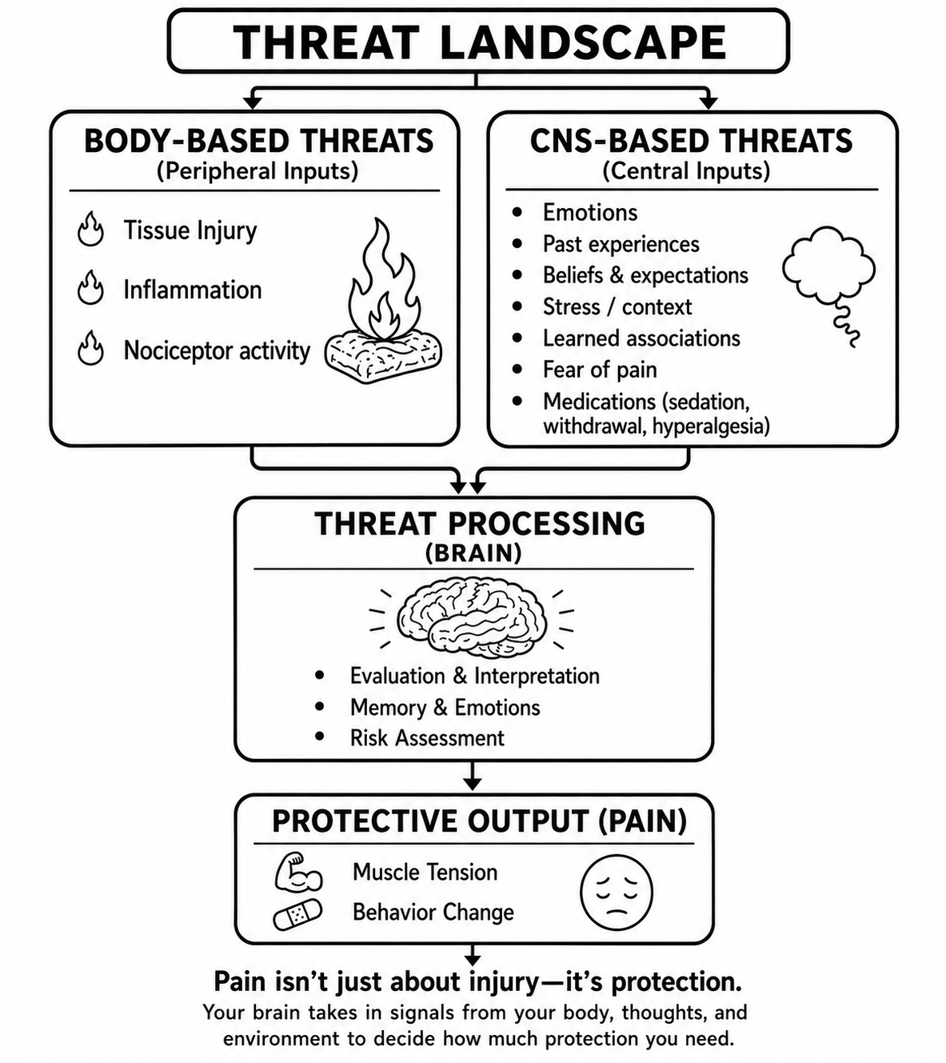
This is what we mean by an overprotective system.
It’s a bit like a smoke detector that goes off when you burn toast. There’s no real fire: but the alarm is still loud and hard to ignore.
The good news? Just like you can adjust a sensitive smoke detector, your nervous system can learn to feel safe again.

Two Different Kinds of Pain

Acute Pain (Short-Term Pain)
Acute pain is helpful. When something harms your body, warning signals travel through the nervous system to the brain. If the brain believes there is danger, it creates pain to get your attention and encourage you to protect the area while it heals.
This is called acute pain. It usually improves as the body heals. It usually makes sense.
Examples include:
- touching a hot stove
- spraining an ankle
- cutting your finger

Chronic Pain
Chronic pain is different from acute pain.
Acute pain is the kind you feel when you sprain an ankle or cut your finger. It shows up to protect you, then settles down as your body heals.
Chronic pain is different. It can continue even after the body has healed.
The original injury may no longer be sending danger signals from your body. Instead, the signals are coming from your nervous system—your brain and spinal cord.
Your brain, like a smoke detector, can’t tell you exactly where the problem is coming from. It just knows something might be wrong. So, it turns on pain to get your attention and tell you to “go look.”
Over time, your body can build “pain pathways,” or circuits. These are like well-used roads in your nervous system that have learned how to turn the alarm on more easily.
First; and this really matters; this is not your fault.
In many ways, your pain system is doing exactly what it’s supposed to do. It’s trying to protect you.
It’s just become a little too good at its job.
Chronic pain is something your body learns. Over time, your nervous system gets better and better at protecting you. The pathways that create pain can become more sensitive and quicker to turn the alarm on.
In other words, your alarm system has learned to react fast—even when the level of danger in your body is low.
It’s like a smoke detector that goes off when you burn toast. There’s no fire, but the alarm is still loud and very real.
Because of this, chronic pain can feel confusing. It may show up without a clear reason. It might come and go, or not follow a pattern that makes sense.
But this does not mean the pain is imagined.
It means your body’s protection system; the alarm designed to keep you safe; has become overprotective. This also helps explain why pain can feel intense even when medical tests look normal.
When the alarm system becomes more sensitive, you may notice:
- pain that feels stronger than expected
- pain that does not follow a clear pattern
- pain that comes and goes
- pain in more than one area of the body even “total body pain”
- other symptoms such as fatigue or poor sleep

Protective Habits That Can Keep the Pain System Active
When pain lasts a long time, the body often develops protective habits without you realizing it.
These protective behaviors like muscle tension or tucking forward make sense when you have an injury. They help protect the body while tissues heal. But when pain becomes chronic, these same protective patterns can sometimes keep the nervous system on high alert and generate more “threats” from your body even though no damage is occurring.
Common protective habits include:
- holding muscles tight
- guarding certain body parts
- changing posture to avoid discomfort
- avoiding movement because of fear of pain
- constantly checking the body for symptoms
The goal is not to force your body to change quickly.
Instead, the goal is to gently teach the nervous system that movement and everyday activities can be safe again. Building awareness of these patterns is often the first step in helping the alarm system dial down.
Bring kindness when you navigate this. You’re doing the best you can in this moment.

A Simple Way to Change your Posture
One helpful way to teach your body to stand more upright is to connect a new skill to something you already do every day.
For example, while you are waiting for the kettle to boil or the microwave to heat your food, you can practice standing tall.
Try this:
- Stand near a countertop so you feel steady and safe.
- Imagine a string gently lifting the top of your head toward the ceiling.
- Let your body lengthen in an easy, relaxed way.
- Gently squeeze your buttock muscles and rock on your feet.
- Take slow, calm breaths.
As you change your posture, you may notice small sensations or brief twinges. This is common and does not mean you are causing harm.
Each time you practice, you are teaching your nervous system that this movement is safe. Over time, your body’s alarm system can begin to quiet down.
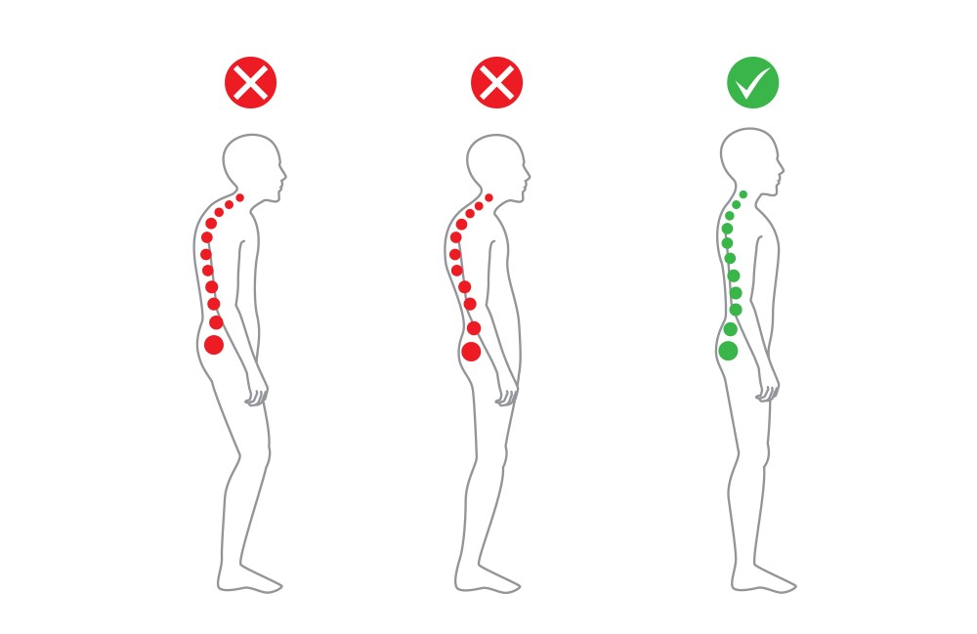

Moving your body with chronic pain will not cause damage
Movement can feel unsafe when you live with chronic pain. This is understandable. Try to bring kindness with you as you begin.
- Start small and build slowly
- Choose movement you enjoy
- Pick places where you feel safe
- Be gentle with yourself—avoid step counters or goals that push intensity, especially those tied to weight loss
- Remind yourself that movement does not mean damage
- Move for the joy of moving, dancing, stretching, or listening to music
It’s normal to notice some discomfort when parts of your body haven’t been used in a while. Although this can feel unpleasant, it does not mean you are causing harm. What matters most is how you interpret the sensation and the thoughts that follow.
It can be helpful to notice your thoughts with curiosity and gently watch for patterns that may increase your sense of threat. For example:
- “How bad is this going to get?”
- “What if I make it worse?”
- “Something must be wrong.”
- “I should stop before I hurt myself.”
These thoughts are very common. They are your brain’s way of trying to protect you.
When you notice them, you don’t need to fight them or push them away. Instead, you can gently respond with reassurance:
“This feels uncomfortable, but it is not dangerous.”
“My body is learning that movement is safe again.”
Over time, this shift, from fear to curiosity and reassurance, can help turn the volume down on the pain alarm.
When you approach movement with a sense of safety, curiosity, and reassurance, you are giving your brain new evidence, teaching it that movement can be safe again.

Managing Chronic pain
Managing chronic pain is not about pushing harder or relying on willpower. Lasting improvement comes from learning new skills, skills that match how chronic pain works. It rarely comes from treatments or medications alone.
Helpful strategies may include:
- Learning how pain works and why it can continue even after healing
- Gentle, gradual movement that feels safe for your body
- Learning to notice pain sensations without fear using science-based tools such as somatic tracking, which can help calm an overprotective pain system. (see below)
- Relaxation and calming techniques
- Using medications carefully to make pain more manageable, rather than trying to make it disappear completely
Somatic tracking
Somatic tracking is a skill that helps retrain the brain’s pain alarm system. Rather than meeting pain with fear, tension, or avoidance, you practice noticing the sensation with curiosity and calm.
The goal is not to force the pain away.
It is to gently pay attention to what you are feeling while reminding yourself that the sensation, though uncomfortable, is safe. Over time, these repeated experiences of safety can help the nervous system become less protective.
By moving at your own pace and responding with reassurance, somatic tracking can help your brain relearn that movement is safe. Take things one step at a time, and celebrate every small win along the way.
Other tools
Hands-on treatments like massage or nerve blocks can also sometimes help in the short term, but they are usually only one part of a larger plan.
You don’t have to figure this out on your own. Pain self-management programs and chronic pain clinics can help you learn and practice these skills. There are also many supports on-line that are cited at the end of this booklet. Nova Scotia Health’s website has information about chronic pain supports available in your local community.
What You Can Do to Help Your Pain
- Don’t put all your eggs in one basket. Waiting to see a “pain specialist” can take time, but there are things you can start doing now.
- Begin building skills to support your pain system. Small steps can make a meaningful difference.
- Gentle activity is safe and can help your body relearn movement.
- Stay connected with your healthcare provider and remain an active part of your care.
- Pain is part of your life, but it does not get to define your whole life.
- Support your body with regular meals, and daily routines.
- Sleep maybe hard to come by but resources such as sleepwell.ca can be helpful.
- Make space for joy, connection, and things that give your life meaning.
- Remember: you are more than your pain.

Key messages to remember
- Pain does not always mean damage
- Movement is safe and necessary
- The nervous system can change
- Your participation matters
- Be kind to yourself

Final words
Chronic pain is real, and it is increasingly treatable. With understanding, support, and practice, many people learn to live fuller lives, even with pain.
You are not broken. And you are not alone.

Helpful resources:
- Pain Canada – paincanada.ca
- People in Pain Portal
- Nova Scotia Pain Self-Management Programs – nshealth.ca
- Book: The Way Out by Alan Gordon
- Curable App
- Somatic Tracking Exercise for Pain Reprocessing Therapy:
https://www.youtube.com/watch?v=GF-BWH4w8ho
Update: March 2026 Dr. M. Allen

